2D Ragdoll Creator Extension

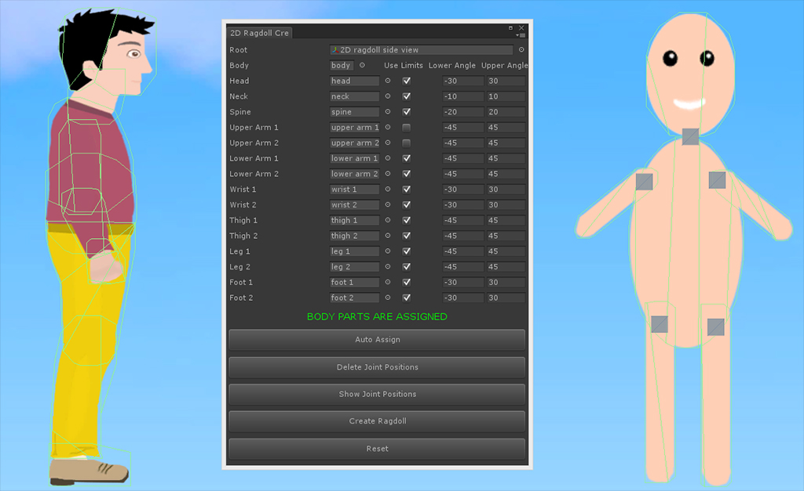

Package Description
This script is editor extension which helps you to create 2D ragdolls fast and easy way.
Also contains few scripts to control ragdolls, drag them by mouse or touch on touch devices, break body parts, play hurt sounds and instantiate blood.
You can use this also on 3D meshes. If they have assigned any 2D collider, it'll be remained if not, polygon colliders will be added to them when creating ragdoll.
It isn't necessary to assign all parts, just don't enter parts which you don't want. You can see ragdoll prefabs with different joint count and style (side, front view).
For now unity doesn’t supports collision disabling for colliders, so created ragdolls must be on layer for which collision is disabled to not blow up ragdoll, because their parts colliders goes through each-other. Collision disabling is done from Editor -> Project Settings -> Physics2D menu.

Package contents
Editor folder contains “2D_Ragdoll_Creator” script which is main part of this project. It creates editor window to create 2D ragdoll.
Material folder – material for blood
Prefabs folder – already created ragdolls (2 type front view, side view, 3D mesh ragdolls)
Scripts folder – scripts to control ragdolls, drag them by mouse or touch on touch devices, break body parts, play hurt sounds and instantiate blood.
Sounds folder – 2 hurt sounds
Sprites folder – sprites for ragdolls, background, blood

2d ragdoll creator window description
You call it from Window -> 2D Ragdoll Creator menu.
You’ll see
Object fields which are used for ragdoll body parts and root object which contains all body parts
Checkboxes - used to set on/off angle limits for each body part
Text fields - to set lower and upper angle limits

5 Buttons
Auto Assign – assigns body parts automatically if they are named suitable. You can see names in ragdoll prefabs
Create/Delete Joint Positions – create/delete square game objects which are used to set positions where joints will be positioned.
Hide/Show Joint Positions – hide/show squares which are used to set joint positions
Create Ragdoll – creates ragdoll (adds 2D colliders, hinge joints, sets anchor and connected anchor positions, connected body, lower and upper limit angles)
Reset – removes all components and clear object fields

scripts description
There are 4 scripts to add fun to ragdolls
BreakJoint – you need to assign this script to any body parts, set velocity and angular velocity to make joint break, also add blood prefab which will be instantiated when joint is broken.
HurtSound – you need to assign this script to any body parts too, set hurt sounds array which will be played randomly when collision velocity is more than “hit velocity for hurt” variable.
Drag – this is attached on camera and is used to drag ragdoll with touch if “for touch screen” checkbox is checked or with cursor. You need to assign dragger game object, which is empty game object with Rigidbody2D and SpringJoint2D components attached.
Restart – restarts scene if more than 2 touch is detected for touch devices or if it is attached on guitext, restarts scene when mouse is clicked on it.

-------------------------------------------------------------------------------
If you have any problems or some suggestions don't hesitate to send me to temo_koki@yahoo.com

Best regards

